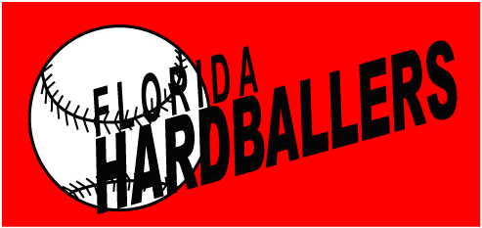
16U White
Summer Schedule 2015

Date | Tournament | Place
5/22-5/25 | PG 16U Memorial Day Classic | Ft. Myers
6/05-6/09 | Vero Beach Classic | Vero Beach
6/17-6/21 | 16U Mizuno State Championship | Kissimmee
6/25-6/30 | Prime Invitational | Winter Haven
7/10-7/17 | PG 16U WWBA | Atlanta
7/29-8/02 | PG 16U FL State Championship | Ft. Myers

